Name: Yash Daga

Roll no:20BCE7323

Q1)Write a program to find minimum value from an array of integers

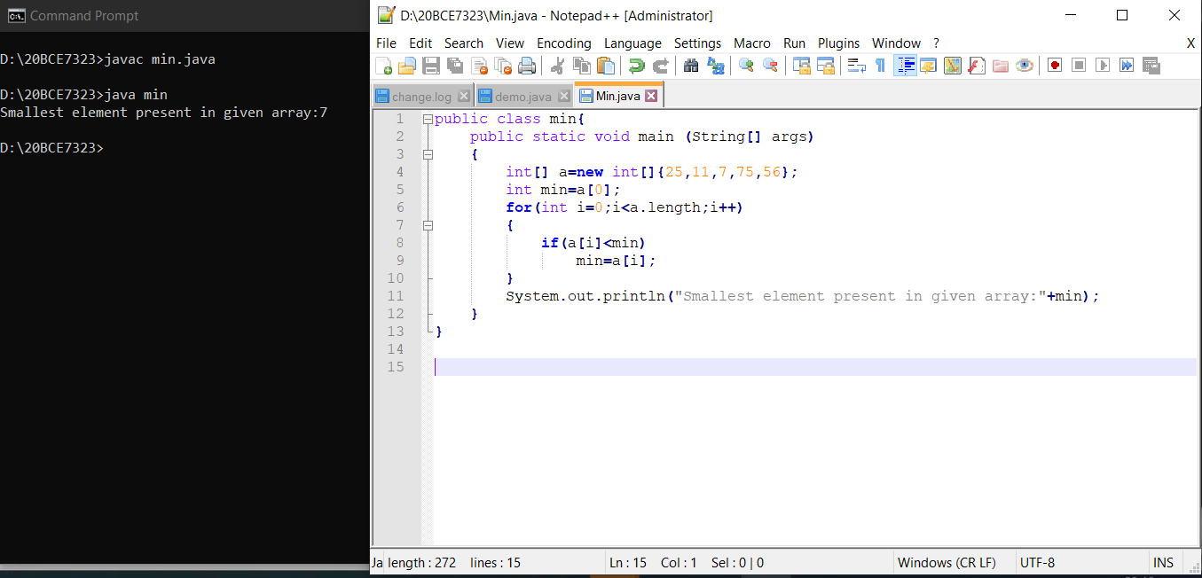

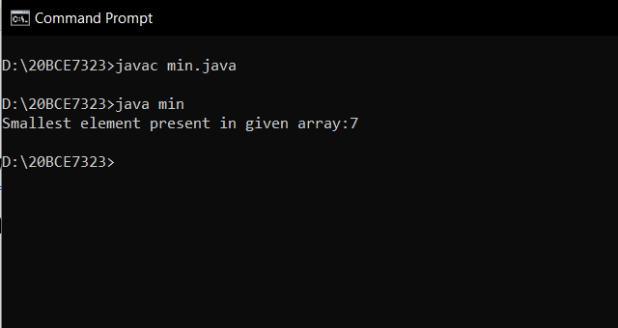

Q2) Write a program to find frequency of each unique number in an array. (Frequency number of times each item appeared in list)

